

LSM 990 + Airyscan 2 User Quick Guide
Software: ZEN 3.13 (Blue Edition)
This guide provides step-by-step instructions for operating the LSM 990 confocal microscope with Airyscan 2.

1. Starting Up the System
- Sign in on the physical log sheet near the microscope.
- Turn on the MAIN SWITCH (Switch 1) on the laser rack located on the left side of the air table.
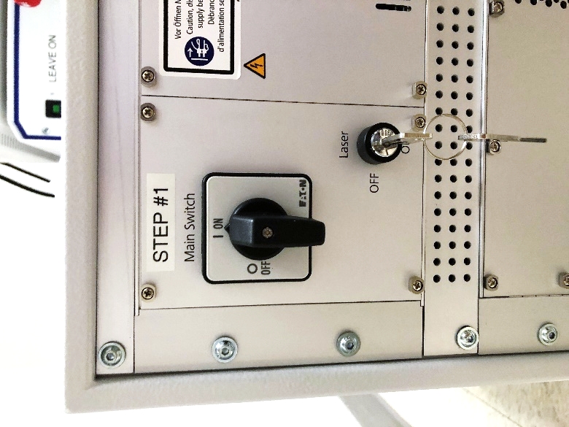
- Turn on the COMPONENTS POWER SWITCH (Switch 2) on the small remote control box.
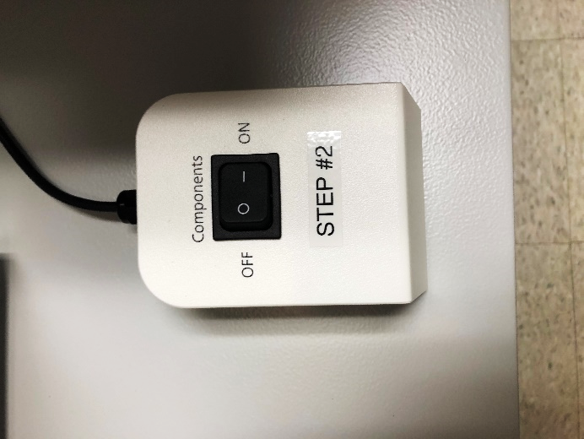
- Turn on the PC POWER BUTTON (Switch 3).
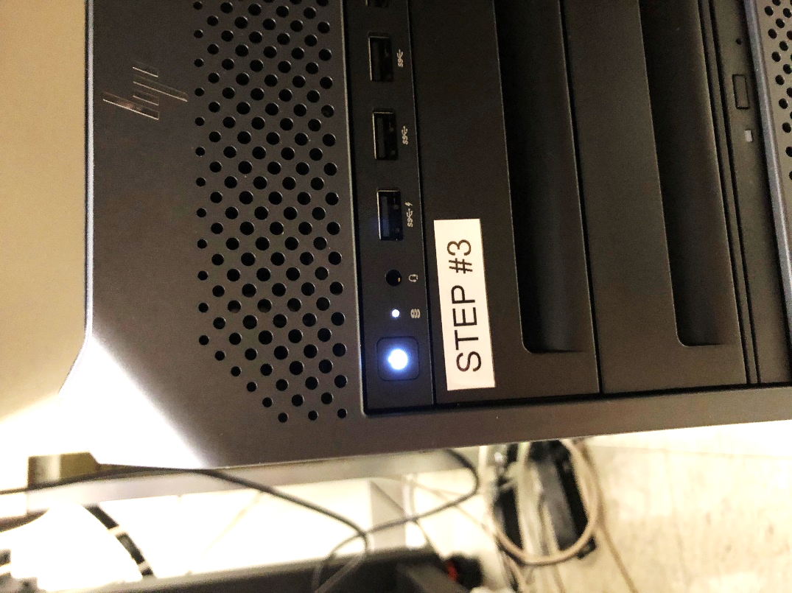
- When the computer finishes booting, log in using your HawkID credentials.

2. Launching ZEN 3 Software
- Double-click on the ZEN 3.13 (Blue) software icon on the desktop.
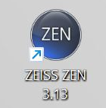
- Select the “Full ZEN Functionality” option to initialize the hardware. (Alternatively, the “Image Processing” mode can be used if only offline data viewing is required.)
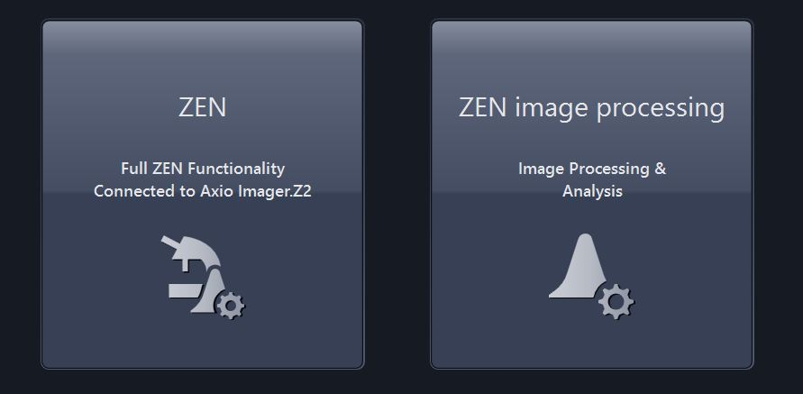

3. Setting Up the Microscope and Locating Specimens
- Click the “Locate” tab to permit access to the binoculars.
- Select the appropriate objective for examining the slide. The 10x lens is a good start.
- Make sure the stage is lowered.
- If using oil immersion (40x, 63x), add a drop of oil directly to the slide. Never use oil on air objectives (e.g. – 10x, 20x), and clean residual oil on slides as necessary.
- Place samples on the stage with coverslip facing upwards.
- Use the stage XY joystick to center the region of interest under the objective lens.
- To view the specimen with fluorescence contrast, click on the suitable Blue, Green or Red preset button.
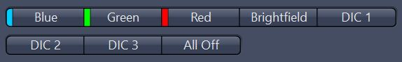
- To view the specimen with Brightfield or DIC contrast (transmitted light), click the appropriate preset button.

4. Configuring Fluorescent Channel Setup
- Click the Acquisition tab.
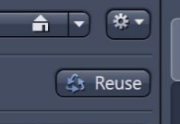

Method 1: Reuse Settings from a Previous Experiment
- Open a previous image (saved with the .CZI file extension) with similar channels; click the “Reuse” button to repopulate all settings from the image.

Method 2: Load a Preset Configuration
- Use the drop-down box to select a pre-defined configuration with an appropriate combination of laser lines required. The “5 Color Tom” experiment is an good default starting point for up to 5 colors.

Method 3: Smart Setup (Alternative Option)
- As a last resort use the “Smart Setup” feature to initialize a stepwise wizard for adding specific fluorophores to the current experiment. The light path will be adjusted based on the given combination, with multiple proposals given to optimize speed, filter flexibility, or a compromise of both.
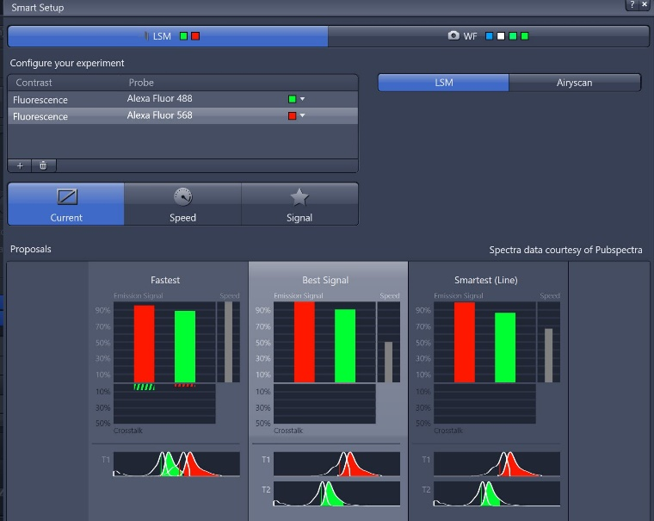

5. Adjusting Scanning Parameters (Acquisition Mode Window)
- In the “Acquisition Mode” window, select “Reset Scan Area”
- Select a Frame Size to represent the desired area per pixel. A value of 1024 x 1024 is a widely-used starting point. The Confocal button will calculate the best possible diffraction-limited sampling for the given wavelength and objective lens but may result in large images.
- Adjust the Scan Speed slider. A setting of 6 – 8 is typical, though noisier samples may benefit from a slower setting.
- Set Direction to bidirectional.
- Select a value for Averaging, which can improve image quality via successive scans with identical settings. A small amount of averaging (2 or 4) is typically more effective at improving signal-to-noise ratios than a slower scan speed.
- Select a dynamic range (8, 16 bit) with the Bits per Pixel setting. 8 bits is often sufficient, but more regimented image quantification may benefit from a 16 bit setting. Note that file sizes will jump significantly with higher bit depths.
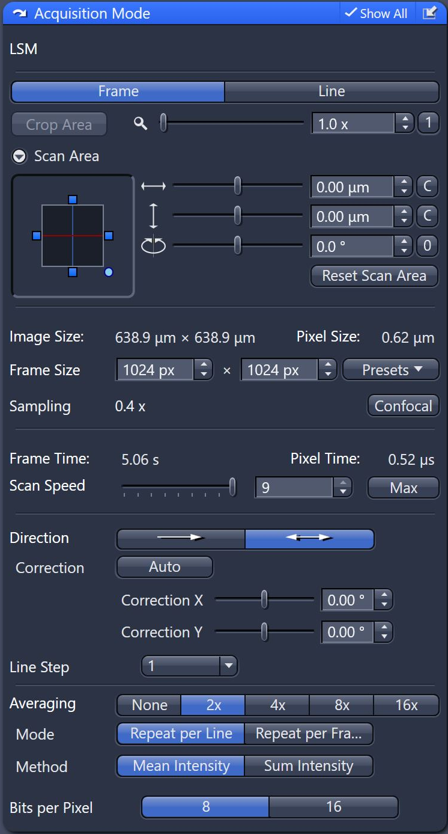

6. Adjusting Channel Sensitivity (Channels Window)
- Set the Pinhole to 1 Airy Unit for the longest-wavelength channel.
- Select one channel (track) in the Channels window.
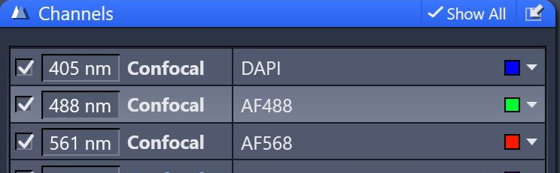
- Click Live to begin a real-time scan.
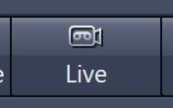
- Enable the Range Indicator display.
  - Saturated pixels are shown as high-intensity indicators.
  - Zero-intensity pixels are shown as low-intensity indicators.
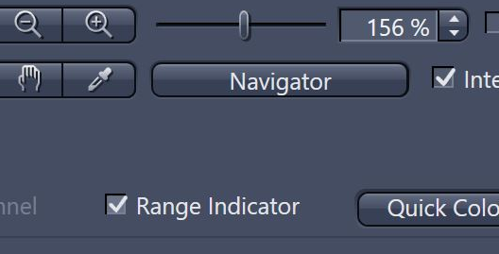
- Adjust sensitivity parameters:
  - Increase Master Gain until minimal saturation appears (avoid values above 850 V).
  - If signal remains low, increase Laser Power (start between 1–3%).
  - Adjust Digital Offset so only minimal background pixels reach zero intensity.
  - Optional: Increase Digital Gain (default 1.5) to stretch the histogram.
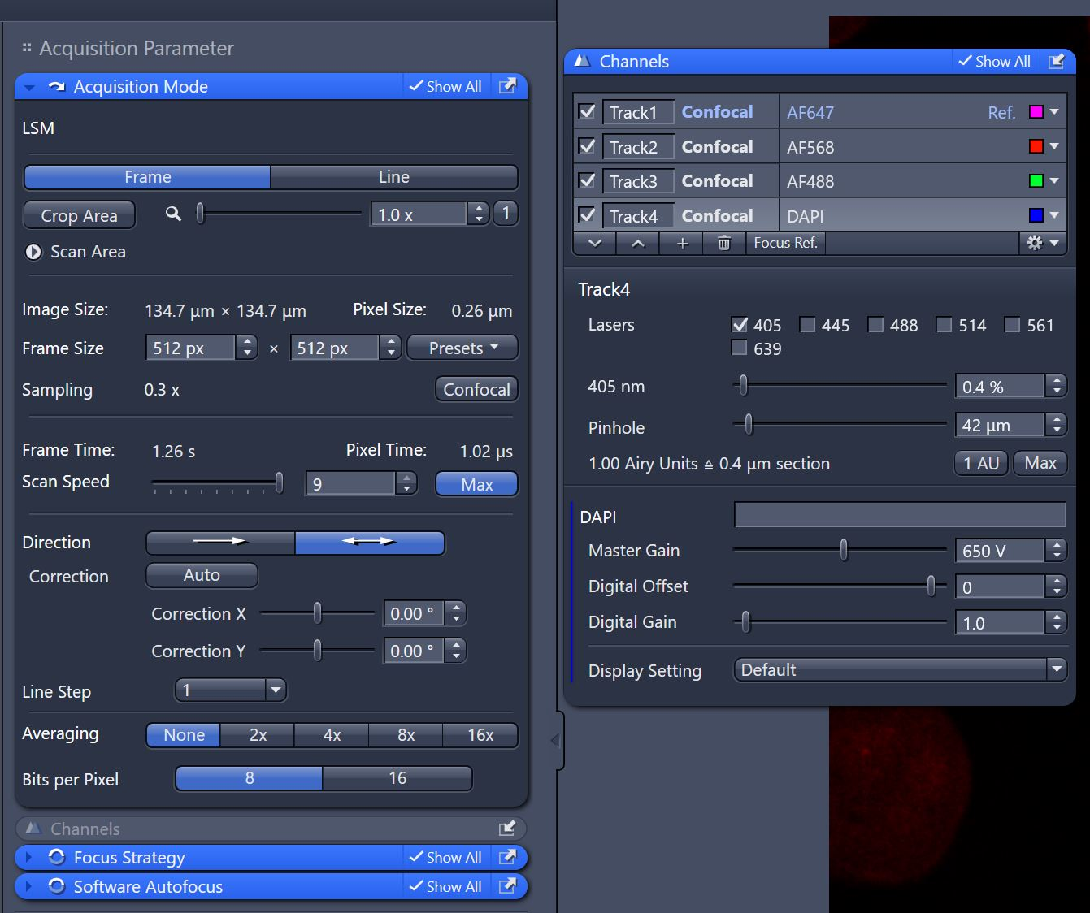
- Repeat these adjustments for each additional channel as needed.

7. Setting Up an Airyscan Experiment
- Move to an Airyscan-optimized objective (typically 63x/1.4 oil, but at least 20x) and ready the specimen.
- Load either a preset configuration – such as “4 Color AS SR” – or use the “Smart Setup” feature, select the Airyscan mode, and add fluorophores. Frame switch mode is recommended.
- Consider adjusting the scan area > 1.7x, as larger empty areas will yield longer scanning time.
- Select one track in the “Channel” window and click the “Continuous” button.
- Adjust the Master Gain and Laser Power (with the help of the Range Indicator tool) to minimize saturation. Extra care should be used in this mode to minimize grossly saturated pixels. As before, avoid use of gains above 850 V. Note that the Pinhole and Digital Offset are not adjustable in this mode.
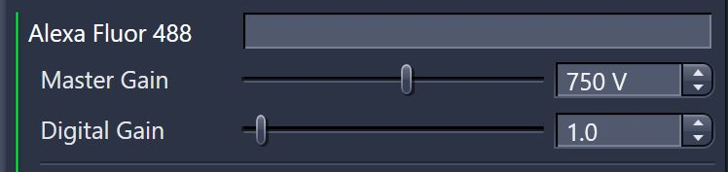
- Click the Airyscan detector view button along the bottom toolbar; confirm that the hexagonal detector view is centered and aligned.
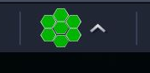
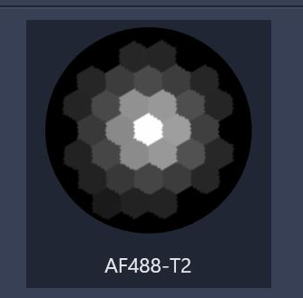
- Repeat steps 4 and 5 for additional tracks/channels as needed.
- Check the optimal settings (e.g. – Frame Size, Scan Area, objective lens) as instructed in the experiment warning(s).
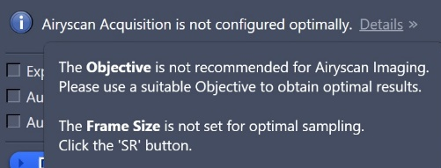
  - Using a superresolution-limited pixel count (“SR”) is critical for maximizing the capabilities of the Airyscan concept. Note that these values may be significantly higher than standard confocal resolution experiments.
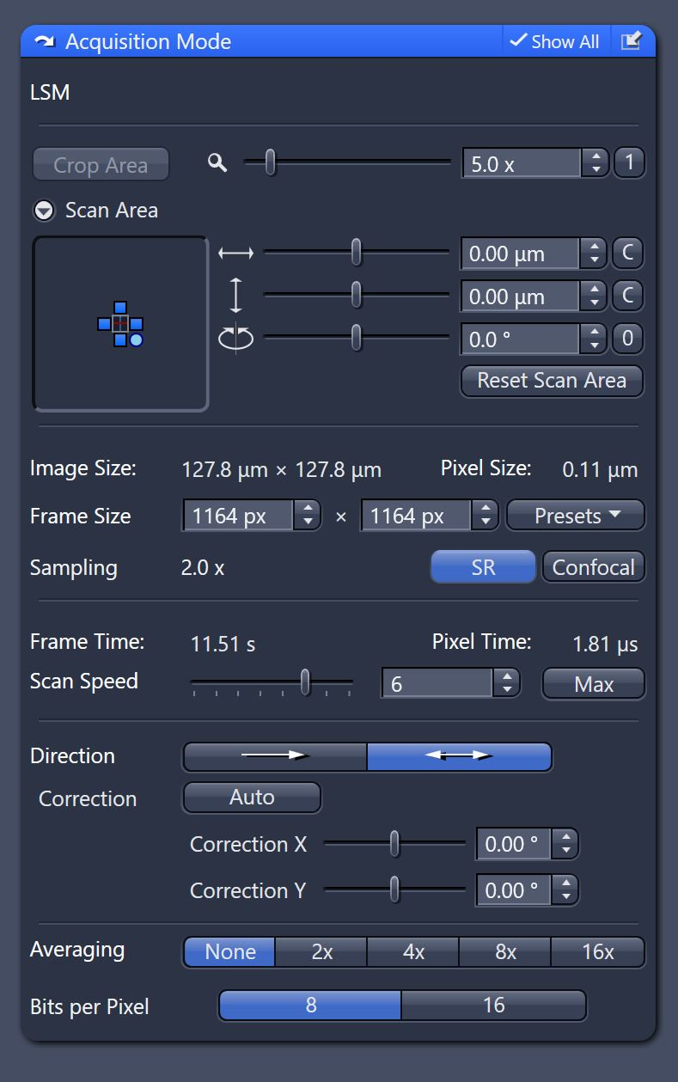
  - The benefits of Averaging are less critical to routine operation of the Airyscan. To keep scan times feasible, consider starting with 1x Averaging values.
  - Raw Airyscan data is efficiently collected with 8-bit data depths; Airyscan processing always yields 16-bit image results.
- Select all tracks and click the “Snap” button and wait for the scanning to complete.
- After the scan, navigate to the “Processing” tab and select Airyscan Processing in the “Methods” window. Apply the setting to generate the pixel-reassigned and deconvolved result.
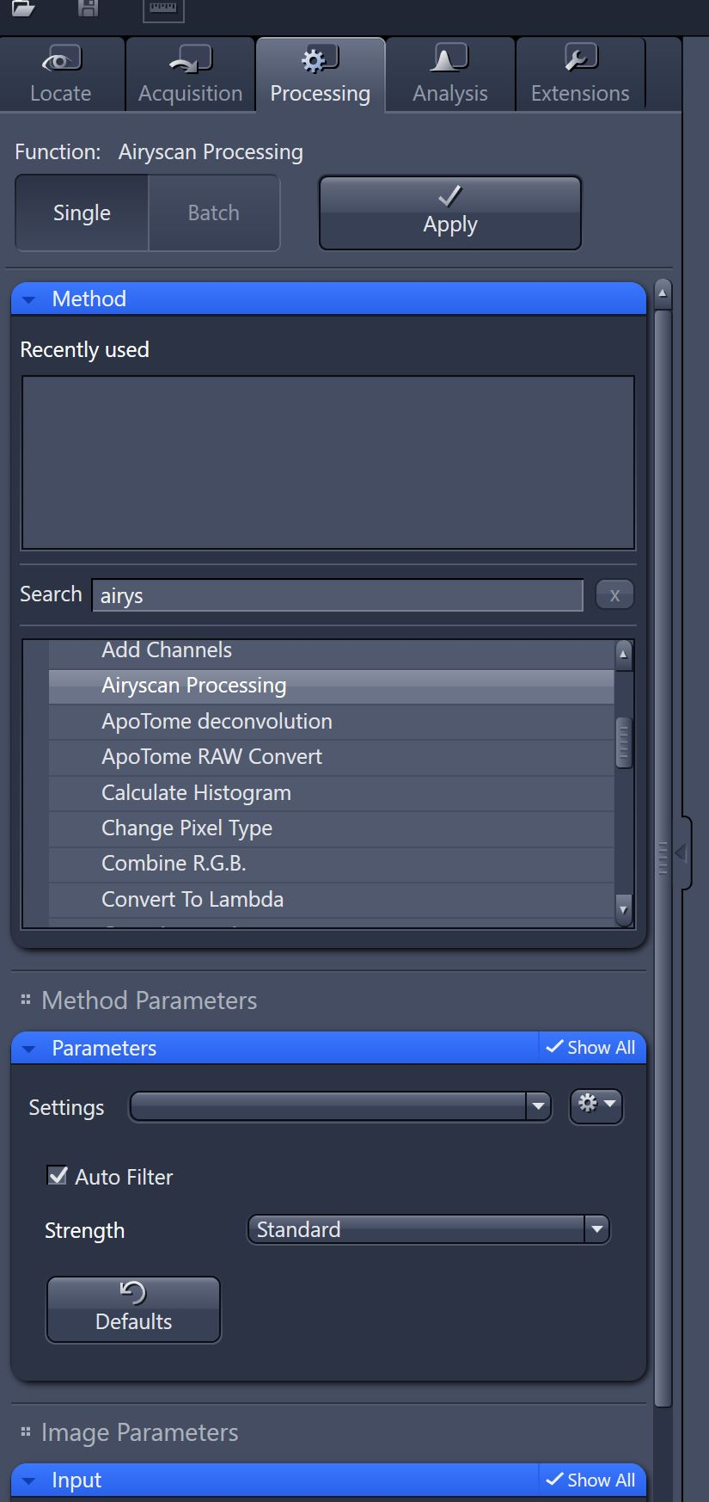

8. Setting Up and Acquiring a Z-Stack
- Activate the Z-Stack checkbox in the main experiment tool area.
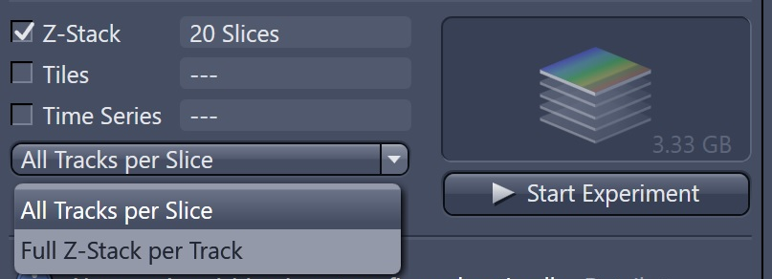
- Select a preferred scanning mode (e.g. – “All Tracks per Slice,” “Full Z-stack per Track”) in the drop-down box. The “All Tracks per Slice” mode is the default, but may be slower for experiments that use multiple filter changes.
- Expand the Z-Stack control window.
- Highlight a channel that exhibits signal throughout the desired sample volume, then click the “Live” button.
  - Use the focus knob to locate one end of the specimen, then click the Set First button.
  - Focus to another end of the specimen, then click the Set Last button. This will mark the total range of the volume. (The relative orientation of the sample does not matter, as the system will always move the focus drive against gravity during acquisition.)
  - Stop the “Live” scan.
  - Set the Interval to define a step size during the Z-stack. For the best 3D reconstruction, consider using the value of the Optimal button. This will yield a sampling step size that is 50% of the optical section thickness of each plane. For routine Z-stacks set the interval to twice the optimal setting.
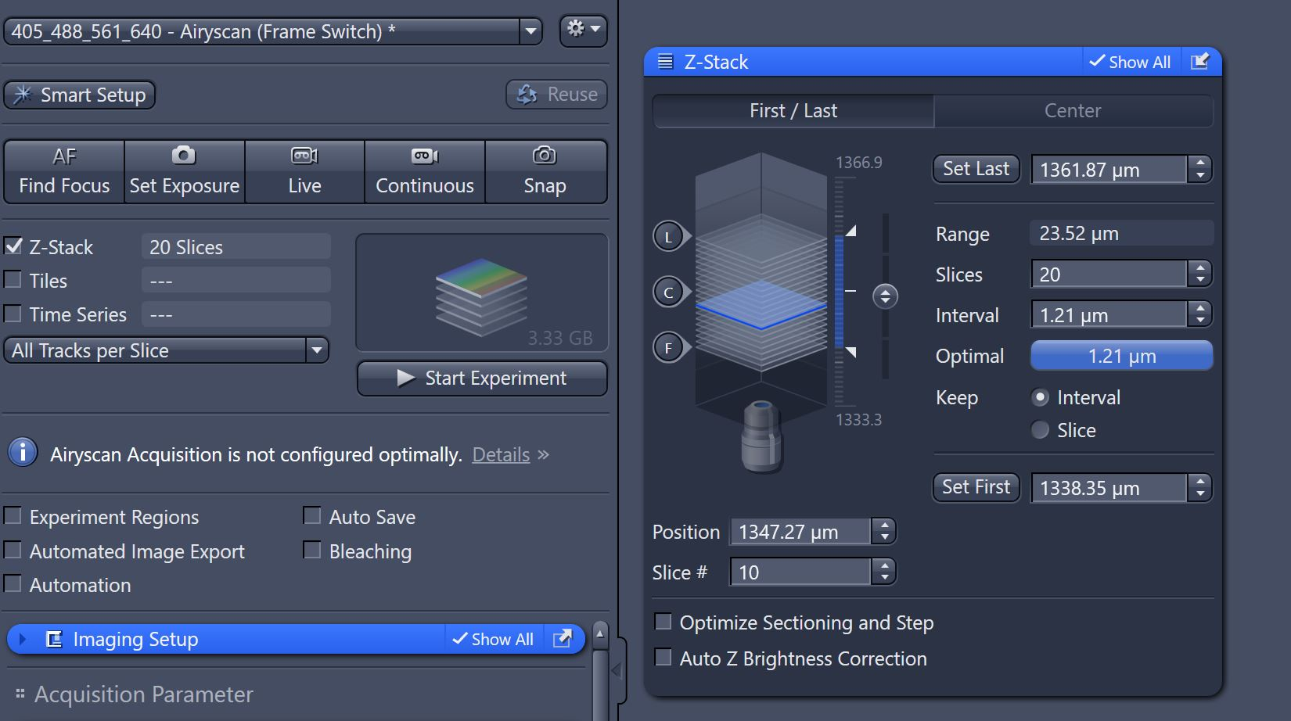

- Click on the Start Experiment button to begin the recording of the Z-Stack scanning. Save the resulting .CZI file.
- Optional – to create a Maximum Intensity Projection image from the stack, navigate to the Ortho tab, which shows a cross-sectional view of the Z-Stack. At the bottom, toggle the “Maximum Intensity Projection” checkbox and wait for the image to process. If a separate image is needed, click the “Create” button at the bottom and select one or more of the axes shown.
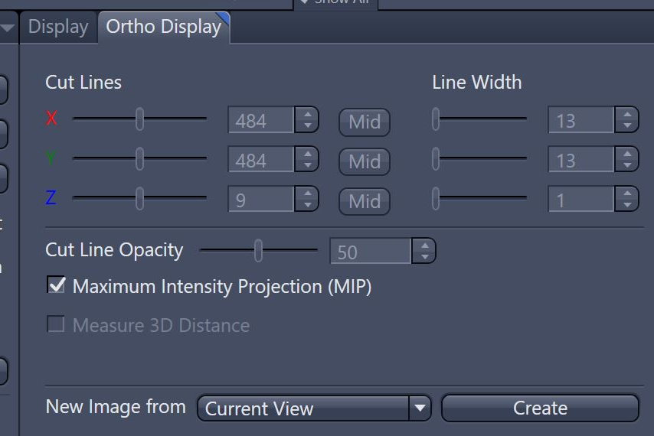
- Optional – to view the sample in the rendering/visualization engine, click the 3D tab on the image. Use the mouse to modify the viewing angle as needed. Snapshots of renders can be generated using the “Create Image” button in the bottom tool tray.

9. Storing and Exporting Data
- To save an acquired or processed image, click on that image in the right tools area to highlight it. Click the Save button (disk icon).
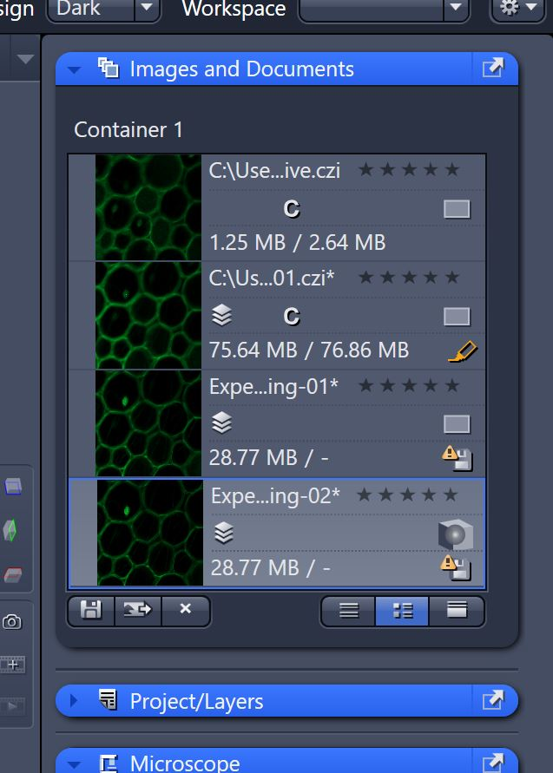
- Create or choose a folder in the D:\ drive of the PC. Enter a file name and save as a .CZI format. Data should not be saved onto the C:\ of the system!
- After saving a copy of the .CZI data (which retains all hardware information used during the experiment), images can be exported to various formats as needed.
  - To export, go to the menu entry File Export Export.
  - In the “Parameters” window, choose the file type and any relevant compression settings.
  - If scale bars do not need to be exported, the “Burn-in Graphics” checkbox can be deselected.
  - Double-check a destination path.
  - Click the “Apply” button at the top.
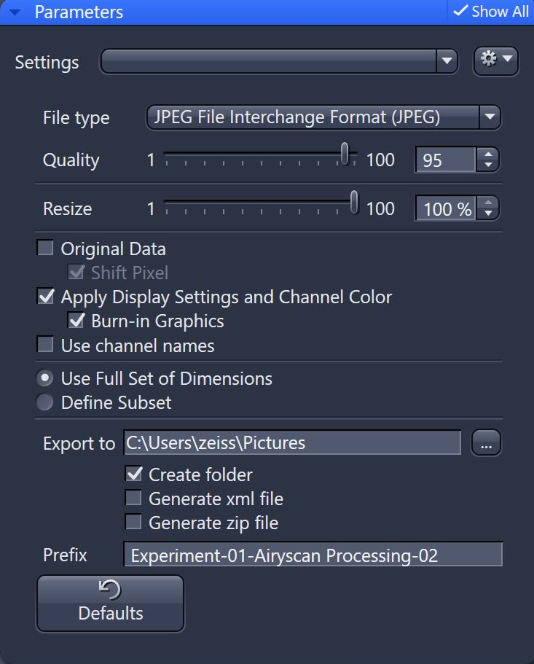

10. Turning Off the System
- Clean off oil from any immersion objectives using lens paper only and lens cleaner.
  - First gently wick up the oil on the objective with a piece of lens paper.
  - Moisten a fresh piece of lens paper with the Lens Cleaner solution; wipe the objective front lens in a slow circular motion.
  - Lightly dry off the Lens Cleaner solution with an additional piece of lens paper.
- Save all needed data.
- Check the BookItLabs scheduler.
  - If it is more than 30 minutes until ne next investigator is signed up: Close the ZEN software, log out of BookIT and shut down the PC (3). Shut off the COMPONENTS (2) switch and the MAIN SWITCH (1) knob.
  - If it is less than 30 minutes until the next investigator close ZEN and logout of BookIT

