

LSM 980 + Airyscan 2: User Quick Guide
Software Version: ZEN 3.3 (Blue Edition)

Starting Up the System
- Sign in on the log sheet.
- Turn on the MAIN SWITCH on the laser rack to the left side of the air table (Step #1).
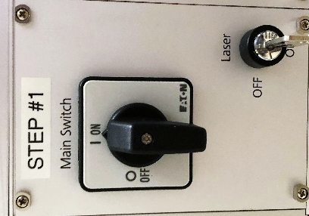
- Turn on the COMPONENTS switch on the small remote box (Step #2).
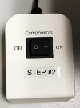
- Turn on the PC power button (Step #3).
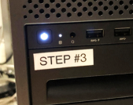
- Once the PC boots up, log in using your HawkID.

Launching the ZEN 3.3 Software
- Double-click on the ZEN 3.3 (Blue) software icon on the desktop.
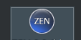
- Select the "ZEN System" option to initialize the hardware. (Alternatively, use "Image Processing" mode for offline data viewing only.)
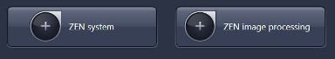

If Performing Live Cell Imaging (Temp, $CO_{2}$, Humidity):
- Check the humidity bottle: Ensure it contains a suitable amount of demineralized water. If low, carefully unscrew the bottom glass bottle and fill it midway. Do not use tap water, as it leaves heavy deposits.
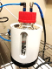
- Activate incubation controls: Go to the right side tool area and locate the "Incubation" window. Activate the required settings for heating, $CO_{2}$, and humidity control.
- Set pump level: Set to 1.
- Stage-surround heating: If using this feature, activate the "Heating XL" checkbox and wait approximately 20 minutes for the temperature to equilibrate.
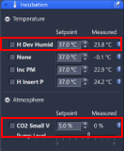

Setting Up the Microscope & Locating Specimens
- Click the "Locate" tab to permit access to the binoculars.
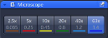
- Select the appropriate objective for examining the slide/dish (the 10x lens is a good starting point).
- Make sure the lens is lowered.
- Immersion Objectives (40x, 63x): Add a drop of water/oil directly to the objective front lens.
Important: Never use water or oil on air objectives (e.g., 10x, 20x). Clean residual water, condensation, or oil on slides as necessary.
- Place samples on the stage with the coverslip facing downwards.
- Use the stage XY joystick to center the objective lens under the area of interest.
- Brightfield Contrast: To view the specimen with transmitted light, click the "Brightfield" preset button found in the "Locate" tab.
- Fluorescence Contrast: Click on the suitable "DAPI," "GFP," or "DsRed" preset buttons.
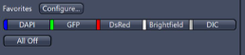

Configuring Fluorescent Channel Setup
Click on the Acquisition tab and select one of the following configuration methods:
- Method #1 (Reuse Previous Settings): Open a previous image (saved with the .CZI file extension) with similar channels, then click the "Reuse" button to repopulate all hardware settings.
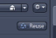
- Method #2 (Pre-defined Configurations): Use the drop-down box to select a pre-defined configuration with the appropriate combination of required laser lines. The "405_488_561_640 – Confocal (Line Switch)" experiment is a good default starting point for up to 4 colors with minimal filter adjustments.
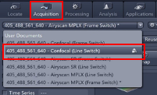
- Method #3 (Smart Setup Wizard): Use the "Smart Setup" feature to initialize a stepwise wizard for adding specific fluorophores. The light path will automatically adjust based on your combination, providing multiple proposals optimized for speed, filter flexibility, or a compromise of both.
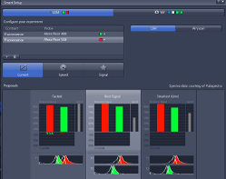

Adjusting Scanning Parameters ("Acquisition Mode" Window)
- Area and Zoom: Select a suitable Area and Zoom setting to capture your area of interest. (Alternatively, use the Crop button after stopping a "Live" image to adjust your desired field of view.)
- Frame Size: Select a Frame Size to represent the desired area per pixel. While a preset value of 1024 x 1024 is a widely used starting point, clicking the "Confocal" button will automatically calculate the best possible diffraction-limited sampling for your given wavelength and objective lens.
- Scan Speed: Adjust the Scan Speed slider. A setting of 6 – 8 is typical, though noisier samples may benefit from a slower setting.
- Direction: Set Direction to bidirectional.
- Averaging: Select a value for Averaging to improve image quality via successive scans. A small amount of averaging (2x or 4x) is typically more effective at improving signal-to-noise ratios than utilizing a slower scan speed.
- Bits per Pixel: Select a dynamic range (8-bit or 16-bit). 8-bit is often sufficient, but regimented image quantification may benefit from 16-bit. Note that file sizes jump significantly at higher bit depths.
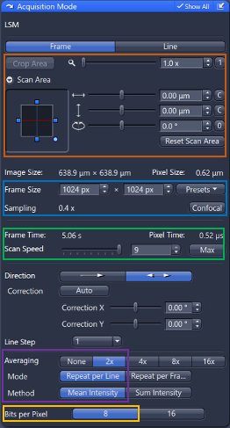

Adjusting Channel Sensitivity ("Channels" Window)
- Set the pinhole slider to 1 AU (Airy Unit) for the longest wavelength channel to maximize optical sectioning capability.
- Highlight a single track in the "Channels" window to view its available parameters.
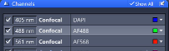
- Click the "Live" button to start a fast XY scan.
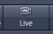
- Activate the Range Indicator checkbox. This toggles the scanned image into a display mode where red pixels indicate saturation (maximum intensity) and blue pixels represent zero value (minimum intensity).
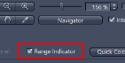
- Fine-tune image sensitivity parameters using these steps:
  - Adjust the focus to identify the brightest or preferred Z-position.
  - Increase the Master Gain until a relatively small amount of red pixels appear in the image. Try to avoid values above 850 V.
  - Increase the Laser Power if the detector gain cannot achieve the desired intensity (values between 1% – 3% are safe starting points).
  - Decrease the Digital Offset to reduce background signal. Use caution, as true signal may be eliminated and actual sensitivity is not altered.
  - Optional: Increase the Digital Gain to amplify all signal and background together, stretching the histogram.
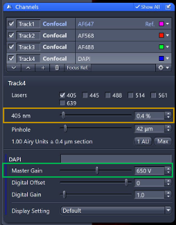
- Repeat these sensitivity steps for additional highlighted tracks/channels as needed.

Setting Up an Airyscan Experiment
- Move to an Airyscan-optimized objective (typically 63x/1.4 Oil) and ready the specimen.
- Load either a preset configuration—such as "405_488_561_640 – Airyscan (Frame Switch)"—or use the "Smart Setup" feature, select the Airyscan mode, and add your fluorophores.
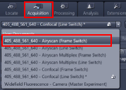
- Consider adjusting the scan area to > 1.7x, as larger empty areas will significantly yield longer scanning times.
- Highlight a track in the "Channels" window and click "Live".
- Adjust the Master Gain and Laser Power using the Range Indicator tool to minimize saturation. Take extra care to avoid grossly saturated pixels, and avoid gains above 850 V. (Note: Pinhole and Digital Offset are not adjustable in this mode.)
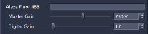
- Click the Airyscan detector view button along the bottom toolbar and confirm that the hexagonal detector view is centered and aligned.
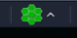
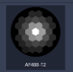
- Repeat the adjustment steps for additional tracks/channels as needed.
- Check for optimal settings (e.g., Frame Size, Scan Area, objective lens) as instructed by any active experiment warning messages.
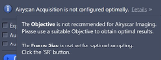
  - Using a superresolution-limited pixel count (“SR”) is critical for maximizing the capabilities of the Airyscan concept. Note that these values may be significantly higher than standard confocal resolution experiments.
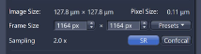
  - The benefits of Averaging are less critical to routine operation of the Airyscan. To keep scan times feasible, consider starting with 1x Averaging values.
  - Raw Airyscan data is efficiently collected with 8-bit data depths; Airyscan processing always yields 16-bit image results.
- Click the "Snap" button and wait for the scan to complete.
- Once complete, navigate to the "Processing" tab, select Airyscan Processing in the "Methods" window, and apply the setting to generate your pixel-reassigned and deconvolved result.
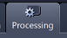
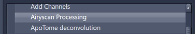
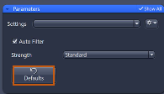

Setting Up and Acquiring a Z-Stack
- Activate the Z-Stack checkbox in the main experiment tool area.
- Select a preferred scanning mode in the drop-down box. "All Tracks per Slice" is the default choice, but may be slower for experiments requiring multiple filter changes. (The alternative is "Full Z-stack per Track".)
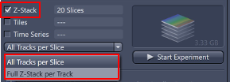
- Expand the Z-Stack control window.
- Highlight a channel that exhibits signal throughout the desired sample volume, then click "Live".
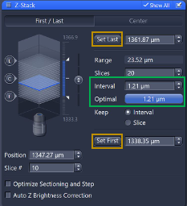
- Use the focus knob to locate one end of the specimen, then click the "Set First" button.
- Focus to the other end of the specimen, then click the "Set Last" button to mark the total volume range. (The relative orientation does not matter; the system automatically moves the focus drive against gravity during acquisition.)
- Stop the "Live" scan.
- Click the "Optimal" button to define the step size Interval. This yields an ideal sampling step size that is 50% of the optical section thickness of each plane.
- Click the "Start Experiment" button to begin recording the Z-Stack. Save the resulting .CZI file.
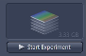

Optional Evaluation Steps:
- Maximum Intensity Projection (MIP): Navigate to the "Ortho" tab (which shows a cross-sectional view of the stack). Toggle the "Maximum Intensity Projection" checkbox at the bottom. To create a separate image file of this view, click the "Create" button and select your preferred axes.
- 3D Visualization: Click the "3D" tab on the image to open the rendering engine. Use the mouse to modify the viewing angle. You can save snapshots using the "Create Image" button in the bottom tool tray.
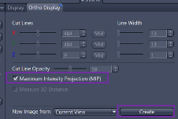

Storing and Exporting Data
- Highlight the image you wish to save in the right tools area, then click the Save button (disk icon).
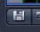
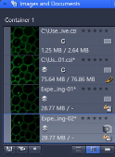
- Choose or create a folder in the D:\ drive of the PC. Enter a file name and save it in .CZI format.
Critical: Data must not be saved onto the local C:\ drive of the system!
- After saving the master .CZI file (which retains all hardware metadata), you can export the image to other formats by going to File $→$ Export $→$ Export.
- In the "Parameters" window, choose your file type and any relevant compression settings.
- If scale bars or annotations are not needed in the export, deselect the "Burn-in Graphics" checkbox.
- Double-check your destination path and click "Apply" at the top.
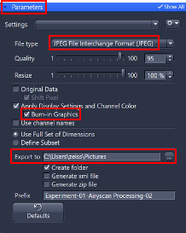

Turning Off the System

1. Clean Immersion Objectives (Lens Paper Only)
- Gently wick up residual oil on the objective using a dry piece of lens paper.
- Moisten a fresh piece of lens paper with the Lens Cleaner solution; wipe the objective front lens in a slow, circular motion.
- Lightly dry off any remaining solution with an additional piece of dry lens paper.

2. General Shutdown Steps
- Save all necessary data.
- If live cell imaging was performed, turn off all heaters in the "Incubation" window of ZEN and close the main valve of the $CO_{2}$ tank.
- Check the BookItLabs scheduler to see when the next user is arriving:
  - If the next user is arriving in MORE than 30 minutes: Close the ZEN software, shut down the PC (3), and turn off the COMPONENTS switch (2) and MAIN SWITCH knob (1).
  - If the next user is arriving in LESS than 30 minutes: Simply close the ZEN software and log out of your Windows session.

