Idea Elan Infinity User Guide

Login link for UIowa investigators:
http://secure7.ideaelan.com/secure/Public/AppLogin.aspx

Login link for external investigators:
https://secure7.ideaelan.com/UIOWA/Public/AppLogin.aspx

After your initial login you should then touch base with your CMRF staff contact and ask to be added to the Infinity scheduling system for the relevant instruments.

- To select Favorite Instruments to be displayed on your HomePage:
  - In instruments tab hover over instrument of choice and click on the star labeled “Favorite.”
  - It will turn blue when selected.
  - The instrument will now be visible on My HomePage, My Favorite Instruments

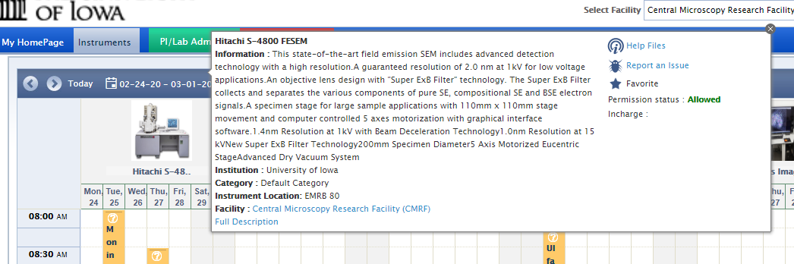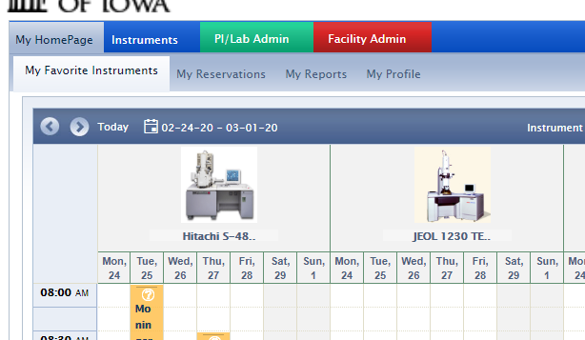
- To Make Reservations
  - Go to My HomePage, My Favorite Instruments
  - Swipe the desired time range and Create Appointment for (the instrument)
  - Edit Subject and other fields as desired and Save

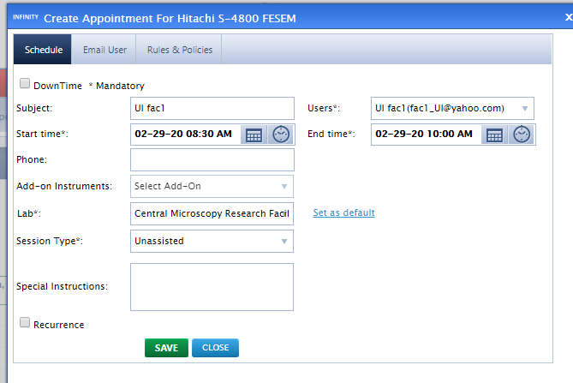

- Note: If you check Sync reservations/task with Outlook in My HomePage, My Profile it will automatically add the appointment to your UI Outlook calendar

