**Instructions for the use of the EMS 150T ES for Iridium coating**

Running a Profile

Before you can run a profile, ensure you have:

Switched on the instrument (rear of the unit, right side).

Turned on Argon cylinder main valve, don’t adjust the regulator.

To run a profile:

1. Load your sample onto the center of the sample stage.

2. Close the top cover assembly and press it firmly down to secure the latch.

3. Tap on the down arrow button to open the dropdown list of profiles with the stylus attached to the right side of the system (see Figure below).

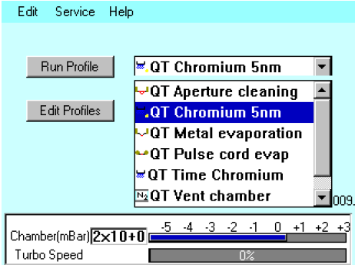

4. Select the profile named “Iridium”. It is a timed run.

5. Click on the Run Profile icon to start the run.

6. At the end of the run, remove samples, turn off Argon main valve, power off the system and make sure you fill out the usage sheet completely.

Notes:

The default settings for Iridium are 20 mA and a bleed vacuum of 1 x 10-2 mbar.

We have found that there is also another change to the parameters that is beneficial for fine grain coating with Iridium (between ~1 nm):

Login as Admin

Change the Argon Bleed gas flush cycle value to 2 or more.

This cycles between 1 x 10-4 and 5 x 10-1 mbar in about 20-30 secs. (this is depending on what you set the bleed gas flush vacuum level to)

